Overview  This document gives steps by step instructions on how to integrate the Mac Operating System with the University of Sydney’s MCS Active Directory infrastructure. Integration with MCS will allow staff to sign onto their Mac Computer using their Unikey credentials and passwords.  Additionally, this document describes the process for migrating the users current Mac profile into the MCS domain profile. This will ensure the user is up and running exactly as they where before integration; migrating documents, application settings, environment settings, keychains and any other settings stored within the users profile.  Migration Overview  The below steps give an overview of the steps required to complete this migration process.  - Remove current local user, ensuring profile data is not disturbed  - Determine configuration settings for migration  - Join Mac to MCS domain  - Configure MacOS domain settings  - Migrate users local profile to the domain users profile  Steps 3-4 have been automated using a script. This allows detailed configuration settings to be hidden form the migration process, and only requires minimal input. It can be considered to be similar to the ‘ProfWiz’ tool for windows.  Migration Steps  - Login as current user  - Ensure that the DTS account exists. If it doesn’t; create it and ensure it has rights to administrator the Mac  - Logout from the users profile, login as DTS.  - Determine the users home directory; see the sidebar for assistance with this.  - Goto Accounts, by opening ‘System Preferences’ and clicking on the ‘Accounts’ icon.  - Remove the users local profile, ensuring to select the option ‘Don’t change the home folder’ Super Important!  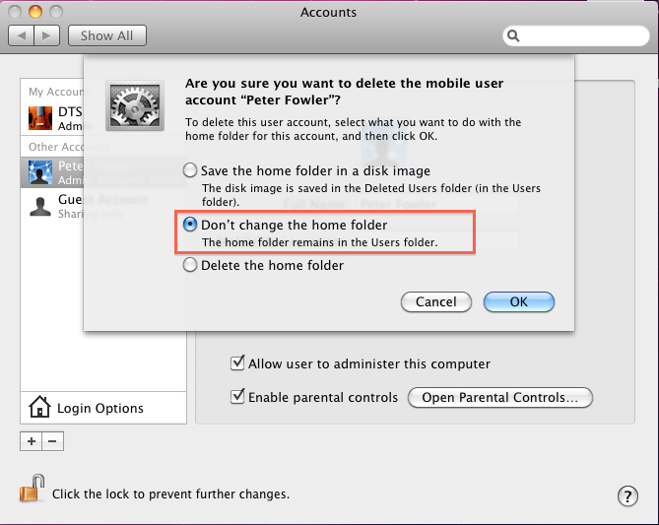  - Now that the profile has been removed, we can begin the migration. Fire up a ‘Terminal’ session, and assume root privileges by typing:  sudo –s  - Determine the USB drive location (See sidebar), and change directory to it. For my USB drive (Which is labeled ‘Untitled’), I type:  cd /Volumes/Untitled/  - So far so good, launch the integration script by typing:  ./macad.sh  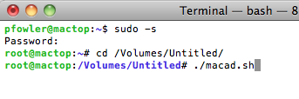  - You will be asked a number of questions:  - The users unikey  - The users home directory. This is case sensitive! (See sidebar for details)  - If the current computer name is longer then 15 characters, you will be asked to enter a shorter one. I’ve been going with unikey_mac  - Your unikey (With privileges to join the machine to the domain)  - Your password  - Once the script has completed, the mac will be joined to the domain, and the users profile migrated to the unikey. Check the script output for any error message, and contact the server team with anything that doesn’t look right. The join can be verified by going to the ‘Account’ settings, and clicking on ‘Login Options’ You should see the MCS domain listed as in the below screenshot.  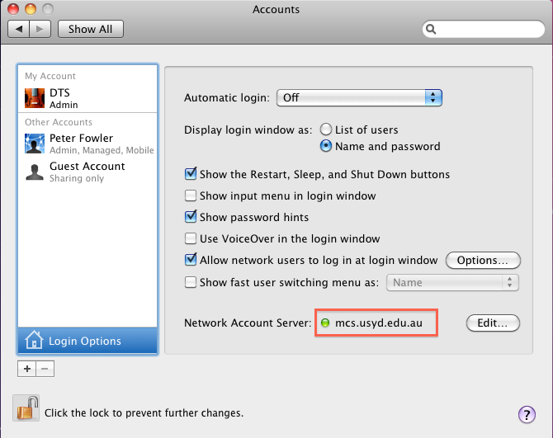  - Now that we are on the domain, log out and get the user to login. They will be prompted with a message to confirm creation of a ‘Mobile Account’ This mobile account will allow the user to login when disconnected from the network, or when the MCS domain servers are unavailable, Explain this to the user and get them to confirm.  - Now take over from the user again, and open up the ‘Account’ settings. Click on the users detail, and allow the user to administrator the Mac (If required, probably not if it’s a shared computer).  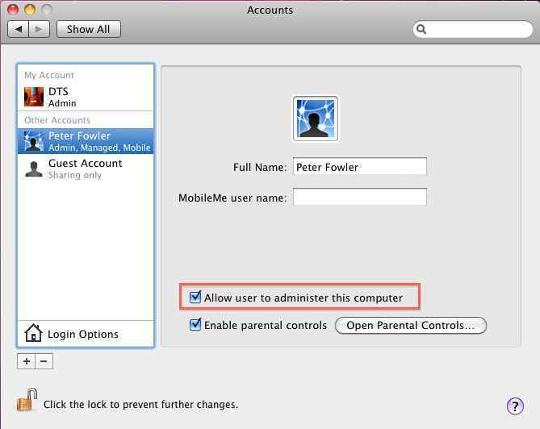  - Setup any home/group shares, and complete any post-migration tasks. |  | Scripts  Two scripts are provided for the migration process:  macad.sh  Joins the Mac to the domain, based on a couple of parameters that are passed to the script and run time.  listhomes.sh  Lists all users and home directories on a Mac system. Run this before removing the user profile if required!  Profile Directory  Finding the user home directory can sometimes be problematic. There can be renamed user accounts attached to differently named profile directory. Sometimes the easiest way is to have a look in the /Users/ directory and take a punt. Otherwise, run the listhomes.sh script. It will print out Real Names, user names and home directories.  Find the USB Path  There isn’t much to finding the USB drive path. Usually, when you intsert the USB drive, a ‘named’ icon will appear on the desktop. The name of the icon is the label name on the USB drive.  To find the path, just append this name to the end of ‘/Volumes/’.  For example, my USB drive doesn’t have a label, so it comes up with the name ‘Untitled’ Therefore, my USB drive path is ‘/Volumes/Untitled’.  You can also use the command ‘mount’ from within a terminal session. It will print out all the currently mounted volumes. With a bit of practice, you’ll be able to identify which ones relate to USB drives.  Other Domain Options  MacOS allows for some other options when joining the MCS domain. These are:  Admin Groups  Determines which groups in the domain will be able to administrator the Mac. Currently set to “Domain Admins”  Network Logins  Determines which users, or groups can log onto the Mac. Might be useful if a user wants tighter security over there Mac. Just adding their name to the network login list will deny all other MCS accounts the ability to logon.  This could also be tied to a group, where we could enable an entire faculty or department access to a Mac, but not to anyone outside of that group.

